Children Against Cases (2016 -2020)

library(readr)  
cases <- read_csv("RS_249_AU3001.csv")

## Rows: 37 Columns: 10  
## ── Column specification ────────────────────────────────────────────────────────  
## Delimiter: ","  
## chr (2): s_no, state  
## dbl (8): complaints_ending_on_01_april_2016, no_of_complaints_received_2016_...  
##   
## ℹ Use `spec()` to retrieve the full column specification for this data.  
## ℹ Specify the column types or set `show_col_types = FALSE` to quiet this message.

#View(cases)  
install.packages("dplyr")

## Installing package into '/cloud/lib/x86_64-pc-linux-gnu-library/4.2'  
## (as 'lib' is unspecified)

library(dplyr)

##   
## Attaching package: 'dplyr'  
##   
## The following objects are masked from 'package:stats':  
##   
## filter, lag  
##   
## The following objects are masked from 'package:base':  
##   
## intersect, setdiff, setequal, union

install.packages("lattice")

## Installing package into '/cloud/lib/x86_64-pc-linux-gnu-library/4.2'  
## (as 'lib' is unspecified)

library(lattice)  
install.packages("ggplot2")

## Installing package into '/cloud/lib/x86_64-pc-linux-gnu-library/4.2'  
## (as 'lib' is unspecified)

library(ggplot2)  
summary(cases)

## s_no state complaints_ending_on_01_april_2016  
## Length:37 Length:37 Min. : 0.0   
## Class :character Class :character 1st Qu.: 3.0   
## Mode :character Mode :character Median : 14.0   
## Mean : 128.8   
## 3rd Qu.: 66.0   
## Max. :2382.0   
## no_of_complaints_received_2016_17 no_of_complaints_received_2017_18  
## Min. : 0.0 Min. : 0.0   
## 1st Qu.: 6.0 1st Qu.: 4.0   
## Median : 26.0 Median : 36.0   
## Mean : 110.7 Mean : 126.4   
## 3rd Qu.: 64.0 3rd Qu.: 83.0   
## Max. :2048.0 Max. :2338.0   
## no_of_complaints_received_2018_19 no_of_complaints_received_2019_20  
## Min. : 0.0 Min. : 0.00   
## 1st Qu.: 4.0 1st Qu.: 1.00   
## Median : 51.0 Median : 7.00   
## Mean : 180.8 Mean : 30.92   
## 3rd Qu.: 132.0 3rd Qu.: 22.00   
## Max. :3344.0 Max. :572.00   
## total total_no_of_complaints_closed cases_pending_on_01_june_2019  
## Min. : 1.0 Min. : 1.0 Min. : 0.0   
## 1st Qu.: 15.0 1st Qu.: 11.0 1st Qu.: 4.0   
## Median : 166.0 Median : 113.0 Median : 44.0   
## Mean : 577.5 Mean : 411.1 Mean : 166.4   
## 3rd Qu.: 442.0 3rd Qu.: 275.0 3rd Qu.: 131.0   
## Max. :10684.0 Max. :7605.0 Max. :3079.0

is.na(cases)

## s_no state complaints_ending_on_01_april_2016  
## [1,] FALSE FALSE FALSE  
## [2,] FALSE FALSE FALSE  
## [3,] FALSE FALSE FALSE  
## [4,] FALSE FALSE FALSE  
## [5,] FALSE FALSE FALSE  
## [6,] FALSE FALSE FALSE  
## [7,] FALSE FALSE FALSE  
## [8,] FALSE FALSE FALSE  
## [9,] FALSE FALSE FALSE  
## [10,] FALSE FALSE FALSE  
## [11,] FALSE FALSE FALSE  
## [12,] FALSE FALSE FALSE  
## [13,] FALSE FALSE FALSE  
## [14,] FALSE FALSE FALSE  
## [15,] FALSE FALSE FALSE  
## [16,] FALSE FALSE FALSE  
## [17,] FALSE FALSE FALSE  
## [18,] FALSE FALSE FALSE  
## [19,] FALSE FALSE FALSE  
## [20,] FALSE FALSE FALSE  
## [21,] FALSE FALSE FALSE  
## [22,] FALSE FALSE FALSE  
## [23,] FALSE FALSE FALSE  
## [24,] FALSE FALSE FALSE  
## [25,] FALSE FALSE FALSE  
## [26,] FALSE FALSE FALSE  
## [27,] FALSE FALSE FALSE  
## [28,] FALSE FALSE FALSE  
## [29,] FALSE FALSE FALSE  
## [30,] FALSE FALSE FALSE  
## [31,] FALSE FALSE FALSE  
## [32,] FALSE FALSE FALSE  
## [33,] FALSE FALSE FALSE  
## [34,] FALSE FALSE FALSE  
## [35,] FALSE FALSE FALSE  
## [36,] FALSE FALSE FALSE  
## [37,] FALSE FALSE FALSE  
## no_of_complaints_received_2016_17 no_of_complaints_received_2017_18  
## [1,] FALSE FALSE  
## [2,] FALSE FALSE  
## [3,] FALSE FALSE  
## [4,] FALSE FALSE  
## [5,] FALSE FALSE  
## [6,] FALSE FALSE  
## [7,] FALSE FALSE  
## [8,] FALSE FALSE  
## [9,] FALSE FALSE  
## [10,] FALSE FALSE  
## [11,] FALSE FALSE  
## [12,] FALSE FALSE  
## [13,] FALSE FALSE  
## [14,] FALSE FALSE  
## [15,] FALSE FALSE  
## [16,] FALSE FALSE  
## [17,] FALSE FALSE  
## [18,] FALSE FALSE  
## [19,] FALSE FALSE  
## [20,] FALSE FALSE  
## [21,] FALSE FALSE  
## [22,] FALSE FALSE  
## [23,] FALSE FALSE  
## [24,] FALSE FALSE  
## [25,] FALSE FALSE  
## [26,] FALSE FALSE  
## [27,] FALSE FALSE  
## [28,] FALSE FALSE  
## [29,] FALSE FALSE  
## [30,] FALSE FALSE  
## [31,] FALSE FALSE  
## [32,] FALSE FALSE  
## [33,] FALSE FALSE  
## [34,] FALSE FALSE  
## [35,] FALSE FALSE  
## [36,] FALSE FALSE  
## [37,] FALSE FALSE  
## no_of_complaints_received_2018_19 no_of_complaints_received_2019_20 total  
## [1,] FALSE FALSE FALSE  
## [2,] FALSE FALSE FALSE  
## [3,] FALSE FALSE FALSE  
## [4,] FALSE FALSE FALSE  
## [5,] FALSE FALSE FALSE  
## [6,] FALSE FALSE FALSE  
## [7,] FALSE FALSE FALSE  
## [8,] FALSE FALSE FALSE  
## [9,] FALSE FALSE FALSE  
## [10,] FALSE FALSE FALSE  
## [11,] FALSE FALSE FALSE  
## [12,] FALSE FALSE FALSE  
## [13,] FALSE FALSE FALSE  
## [14,] FALSE FALSE FALSE  
## [15,] FALSE FALSE FALSE  
## [16,] FALSE FALSE FALSE  
## [17,] FALSE FALSE FALSE  
## [18,] FALSE FALSE FALSE  
## [19,] FALSE FALSE FALSE  
## [20,] FALSE FALSE FALSE  
## [21,] FALSE FALSE FALSE  
## [22,] FALSE FALSE FALSE  
## [23,] FALSE FALSE FALSE  
## [24,] FALSE FALSE FALSE  
## [25,] FALSE FALSE FALSE  
## [26,] FALSE FALSE FALSE  
## [27,] FALSE FALSE FALSE  
## [28,] FALSE FALSE FALSE  
## [29,] FALSE FALSE FALSE  
## [30,] FALSE FALSE FALSE  
## [31,] FALSE FALSE FALSE  
## [32,] FALSE FALSE FALSE  
## [33,] FALSE FALSE FALSE  
## [34,] FALSE FALSE FALSE  
## [35,] FALSE FALSE FALSE  
## [36,] FALSE FALSE FALSE  
## [37,] FALSE FALSE FALSE  
## total_no_of_complaints_closed cases_pending_on_01_june_2019  
## [1,] FALSE FALSE  
## [2,] FALSE FALSE  
## [3,] FALSE FALSE  
## [4,] FALSE FALSE  
## [5,] FALSE FALSE  
## [6,] FALSE FALSE  
## [7,] FALSE FALSE  
## [8,] FALSE FALSE  
## [9,] FALSE FALSE  
## [10,] FALSE FALSE  
## [11,] FALSE FALSE  
## [12,] FALSE FALSE  
## [13,] FALSE FALSE  
## [14,] FALSE FALSE  
## [15,] FALSE FALSE  
## [16,] FALSE FALSE  
## [17,] FALSE FALSE  
## [18,] FALSE FALSE  
## [19,] FALSE FALSE  
## [20,] FALSE FALSE  
## [21,] FALSE FALSE  
## [22,] FALSE FALSE  
## [23,] FALSE FALSE  
## [24,] FALSE FALSE  
## [25,] FALSE FALSE  
## [26,] FALSE FALSE  
## [27,] FALSE FALSE  
## [28,] FALSE FALSE  
## [29,] FALSE FALSE  
## [30,] FALSE FALSE  
## [31,] FALSE FALSE  
## [32,] FALSE FALSE  
## [33,] FALSE FALSE  
## [34,] FALSE FALSE  
## [35,] FALSE FALSE  
## [36,] FALSE FALSE  
## [37,] FALSE FALSE

names(cases)

## [1] "s_no" "state"   
## [3] "complaints_ending_on_01_april_2016" "no_of_complaints_received_2016_17"   
## [5] "no_of_complaints_received_2017_18" "no_of_complaints_received_2018_19"   
## [7] "no_of_complaints_received_2019_20" "total"   
## [9] "total_no_of_complaints_closed" "cases_pending_on_01_june_2019"

str(cases)

## spc_tbl_ [37 × 10] (S3: spec_tbl_df/tbl_df/tbl/data.frame)  
## $ s_no : chr [1:37] "1" "2" "3" "4" ...  
## $ state : chr [1:37] "Andaman & Nicobar Islands" "Andhra Pradesh" "Arunachal Pradesh" "Assam" ...  
## $ complaints_ending_on_01_april_2016: num [1:37] 0 469 2 14 80 4 12 0 0 134 ...  
## $ no_of_complaints_received_2016_17 : num [1:37] 1 25 0 18 64 9 53 0 1 291 ...  
## $ no_of_complaints_received_2017_18 : num [1:37] 4 40 5 33 73 12 47 1 0 266 ...  
## $ no_of_complaints_received_2018_19 : num [1:37] 5 51 4 28 200 8 72 0 0 378 ...  
## $ no_of_complaints_received_2019_20 : num [1:37] 0 7 3 6 25 3 7 0 0 65 ...  
## $ total : num [1:37] 10 592 14 99 442 ...  
## $ total_no_of_complaints_closed : num [1:37] 8 439 7 78 267 31 124 1 1 786 ...  
## $ cases_pending_on_01_june_2019 : num [1:37] 2 153 7 21 174 5 68 0 0 359 ...  
## - attr(*, "spec")=  
## .. cols(  
## .. s_no = col_character(),  
## .. state = col_character(),  
## .. complaints_ending_on_01_april_2016 = col_double(),  
## .. no_of_complaints_received_2016_17 = col_double(),  
## .. no_of_complaints_received_2017_18 = col_double(),  
## .. no_of_complaints_received_2018_19 = col_double(),  
## .. no_of_complaints_received_2019_20 = col_double(),  
## .. total = col_double(),  
## .. total_no_of_complaints_closed = col_double(),  
## .. cases_pending_on_01_june_2019 = col_double()  
## .. )  
## - attr(*, "problems")=<externalptr>

data = cases[-37,]  
data

## # A tibble: 36 × 10  
## s_no state compl…¹ no_of…² no_of…³ no_of…⁴ no_of…⁵ total total…⁶ cases…⁷  
## <chr> <chr> <dbl> <dbl> <dbl> <dbl> <dbl> <dbl> <dbl> <dbl>  
## 1 1 Andaman … 0 1 4 5 0 10 8 2  
## 2 2 Andhra P… 469 25 40 51 7 592 439 153  
## 3 3 Arunacha… 2 0 5 4 3 14 7 7  
## 4 4 Assam 14 18 33 28 6 99 78 21  
## 5 5 Bihar 80 64 73 200 25 442 267 174  
## 6 6 Chandiga… 4 9 12 8 3 36 31 5  
## 7 7 Chhattis… 12 53 47 72 7 191 124 68  
## 8 8 Dadra an… 0 0 1 0 0 1 1 0  
## 9 9 Daman an… 0 1 0 0 0 1 1 0  
## 10 10 Delhi 134 291 266 378 65 1134 786 359  
## # … with 26 more rows, and abbreviated variable names  
## # ¹​complaints_ending_on_01_april_2016, ²​no_of_complaints_received_2016_17,  
## # ³​no_of_complaints_received_2017_18, ⁴​no_of_complaints_received_2018_19,  
## # ⁵​no_of_complaints_received_2019_20, ⁶​total_no_of_complaints_closed,  
## # ⁷​cases_pending_on_01_june_2019

summary(data)

## s_no state complaints_ending_on_01_april_2016  
## Length:36 Length:36 Min. : 0.00   
## Class :character Class :character 1st Qu.: 2.75   
## Mode :character Mode :character Median : 13.00   
## Mean : 66.17   
## 3rd Qu.: 51.00   
## Max. :848.00   
## no_of_complaints_received_2016_17 no_of_complaints_received_2017_18  
## Min. : 0.00 Min. : 0.00   
## 1st Qu.: 5.00 1st Qu.: 4.00   
## Median : 25.50 Median : 35.50   
## Mean : 56.89 Mean : 64.94   
## 3rd Qu.: 61.75 3rd Qu.: 78.50   
## Max. :537.00 Max. :523.00   
## no_of_complaints_received_2018_19 no_of_complaints_received_2019_20  
## Min. : 0.00 Min. : 0.00   
## 1st Qu.: 3.75 1st Qu.: 1.00   
## Median : 49.00 Median : 6.50   
## Mean : 92.89 Mean : 15.89   
## 3rd Qu.:126.75 3rd Qu.: 22.00   
## Max. :885.00 Max. :203.00   
## total total_no_of_complaints_closed cases_pending_on_01_june_2019  
## Min. : 1.00 Min. : 1.0 Min. : 0.00   
## 1st Qu.: 14.75 1st Qu.: 10.5 1st Qu.: 3.50   
## Median : 163.00 Median : 112.0 Median : 42.00   
## Mean : 296.78 Mean : 211.2 Mean : 85.53   
## 3rd Qu.: 385.00 3rd Qu.: 269.0 3rd Qu.:119.75   
## Max. :2996.00 Max. :2207.0 Max. :780.00

#View(data)

#Total no. of cases each state

plot1 = ggplot(data,aes(x = state ,y = total,  
 fill = total))+  
 geom_bar(stat = "identity")+theme(axis.text.x = element_text(angle = 90))  
plot1

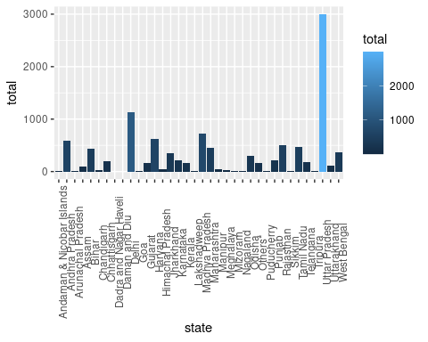

#Complaints pending on April 2016

plot2 = ggplot(data,aes(x = state ,y = complaints_ending_on_01_april_2016,  
 fill = complaints_ending_on_01_april_2016))+  
 geom_bar(stat = "identity")+theme(axis.text.x = element_text(angle = 90))  
plot2

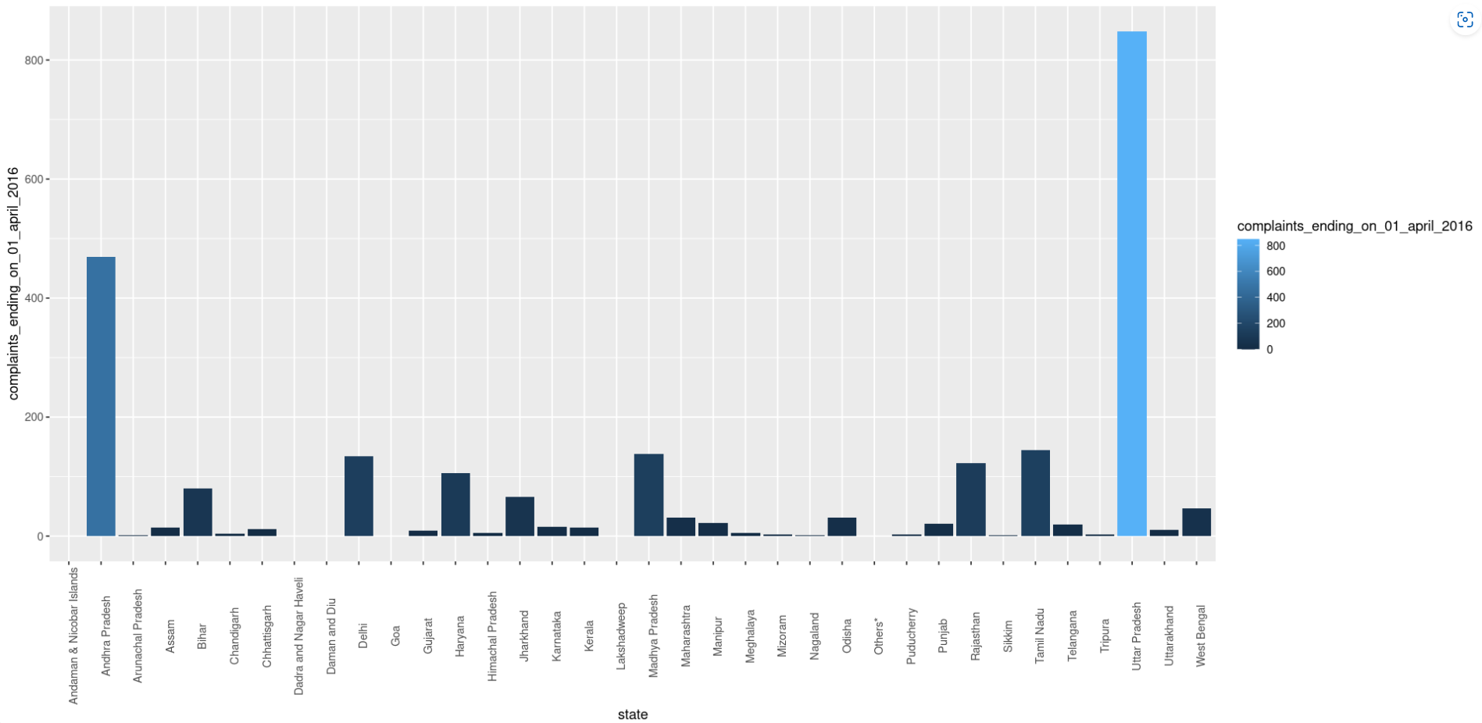

# Complaints received from 2016-2017

plot3 = ggplot(data,aes(x = state ,y = no_of_complaints_received_2016_17,

fill = no_of_complaints_received_2016_17))+  
 geom_bar(stat = "identity")+theme(axis.text.x = element_text(angle = 90))  
plot3

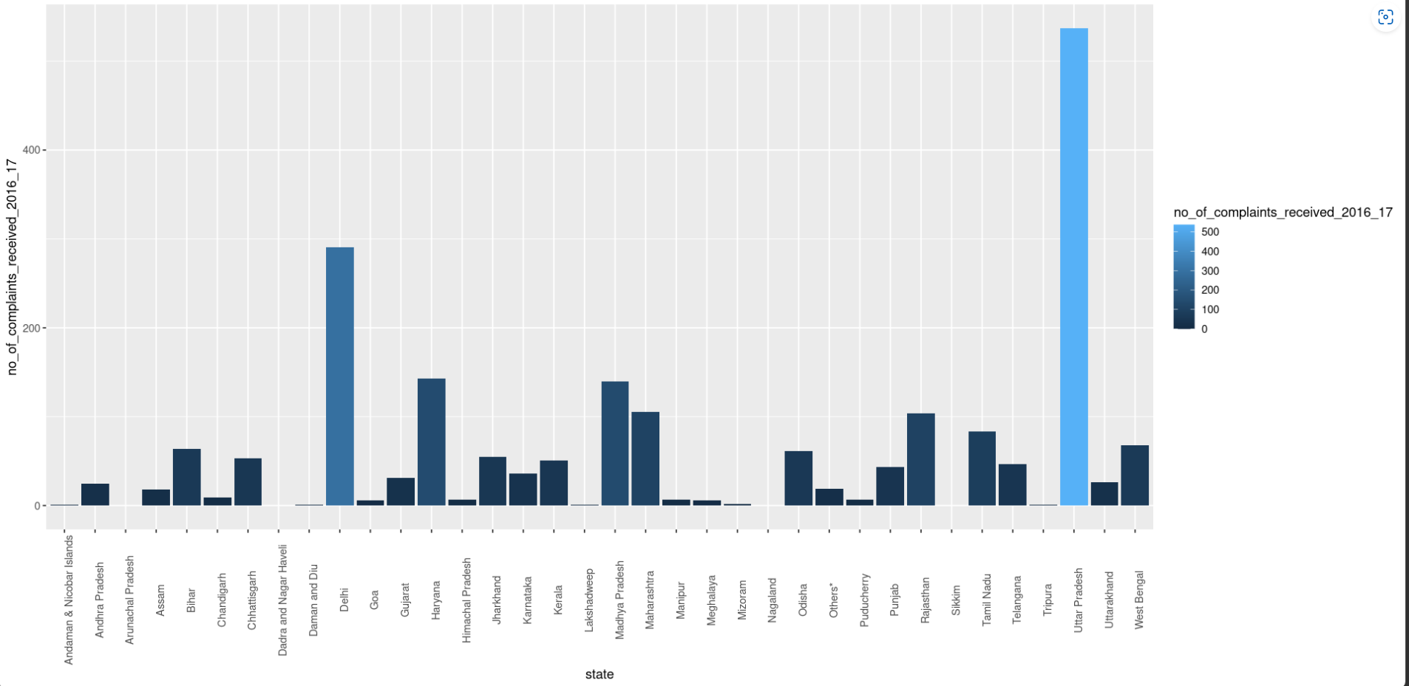

#Complaints received from 2017-2018

plot4 = ggplot(data,aes(x = state ,y = no_of_complaints_received_2017_18,  
 fill = no_of_complaints_received_2017_18))+  
 geom_bar(stat = "identity")+theme(axis.text.x = element_text(angle = 90))  
plot4

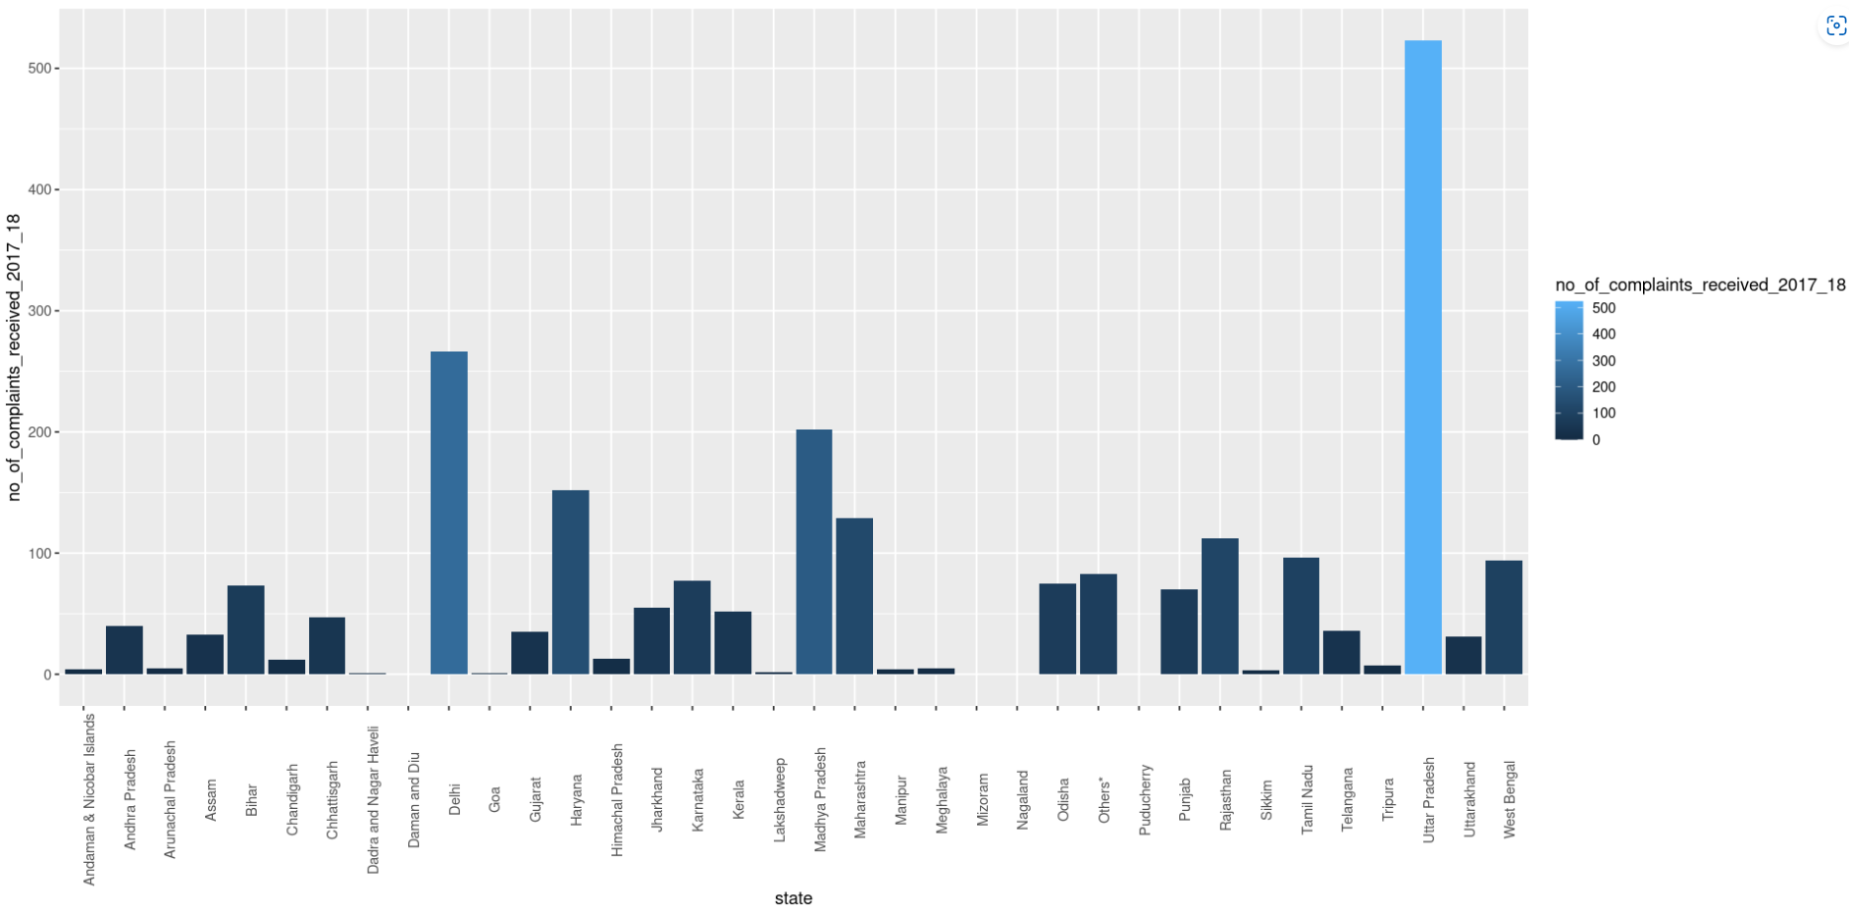

#Complaints received from 2018-2019

plot5 = ggplot(data,aes(x = state ,y = no_of_complaints_received_2018_19,  
 fill = no_of_complaints_received_2018_19))+  
 geom_bar(stat = "identity")+theme(axis.text.x = element_text(angle = 90))  
plot5

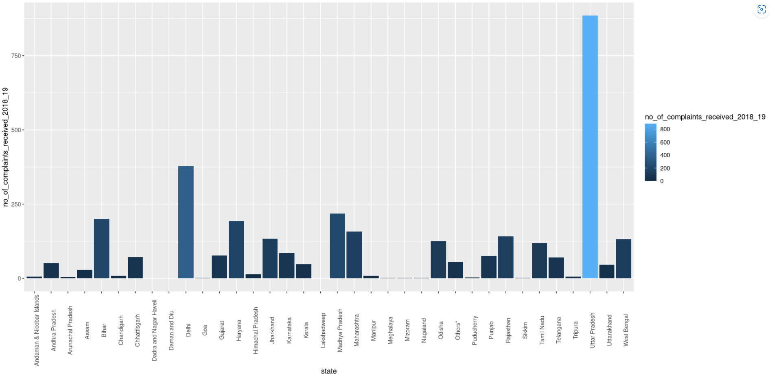

#Complaints received from 2019 to 2020

plot6 = ggplot(data,aes(x = state ,y = no_of_complaints_received_2019_20,  
 fill = no_of_complaints_received_2019_20))+  
 geom_bar(stat = "identity")+theme(axis.text.x = element_text(angle = 90))  
plot6

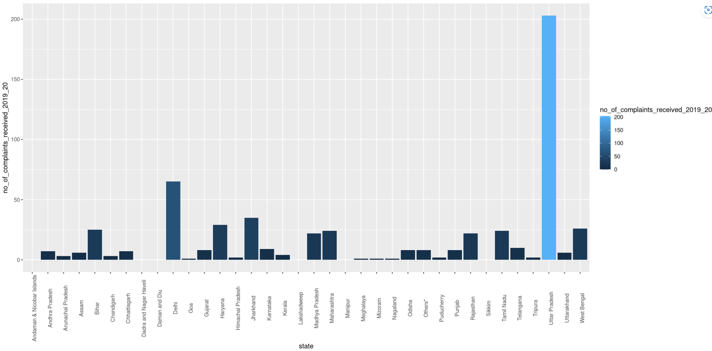

#Complaints closed

plot7 = ggplot(data,aes(x = state ,y =total_no_of_complaints_closed,  
 fill = total_no_of_complaints_closed))+  
 geom_bar(stat = "identity")+theme(axis.text.x = element_text(angle = 90))  
plot7

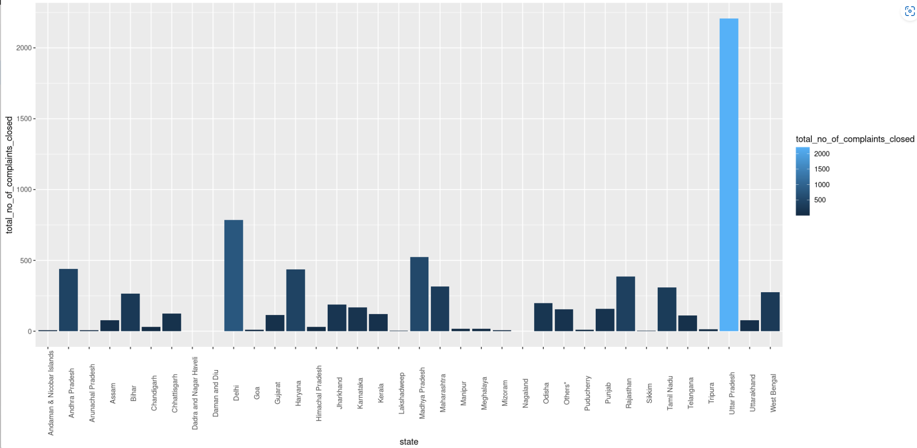

# cases pending on 2019

plot8= ggplot(data,aes(x = state ,y =cases_pending_on_01_june_2019,  
 fill = cases_pending_on_01_june_2019))+  
 geom_bar(stat = "identity")+theme(axis.text.x = element_text(angle = 90))  
plot8

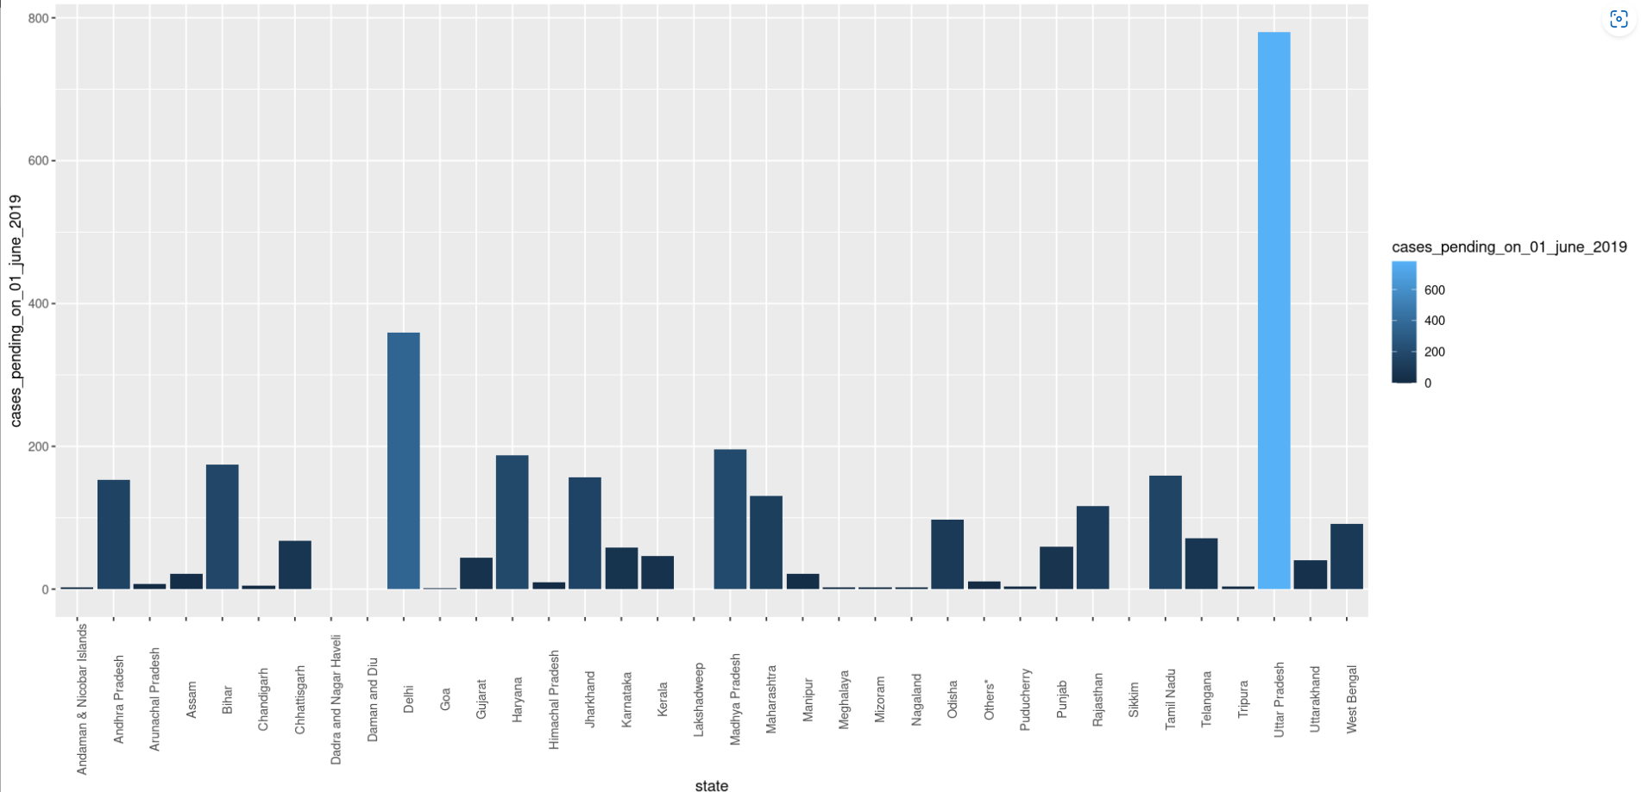

# comparing the cases pending on April 2016 and June 2019

correlate = ggplot(data, aes(x=total)) +   
 geom_line(aes(y = complaints_ending_on_01_april_2016 ),  
 color = "darkred") +   
 geom_line(aes(y = cases_pending_on_01_june_2019),  
 color="steelblue", linetype="twodash")   
  
correlate

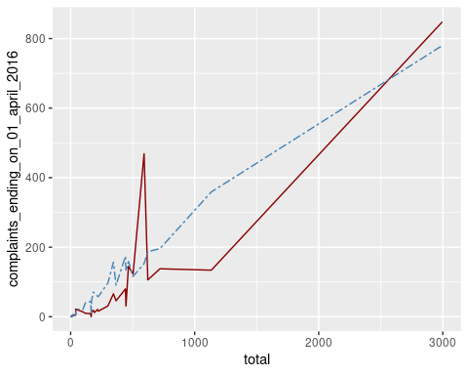

Inference:

The above data set is about the cases against the children which is from pending cases in the April 2016 ,June 2019 and the cases received from 2016 – 2019. From the analysis we can figure that the Uttara Pradesh has received a greater number of cases in India. From 2016 to 2019 the Delhi and Uttara Pradesh has received maximum number of cases.

The pending cases in year 2016 are from Andhra Pradesh and Uttara Pradesh and in the year of 2019 the cases received from Delhi and Andhra Pradesh has received maximum number of cases but the Uttara Pradesh has more the range of 200 .

When we analysis the pending cases in both the year 2016 and 2019 there is a various difference between the cases received.

Insight:

From this analysis we could find that the pending cases has been reduced from the year 2016 when compared to 2019.

This shows that the state Andhra , Delhi has received maximum cases but Uttara Pradesh has more number of cases which is pending and still it receive the cases . This can be reduced by solving the cases as soon as possible with great consent that may give better result of receiving not more cases.